Artwork proposal form 25/26
This form outlines your proposal for a scheme of work leading to the Final Project in Computational Arts.

Student name: Ashley Sagar
Student ID: 33193056
Student email: asaga002@gold.ac.uk

Artwork overview

- Short summary
Give a short summary of the work you want to make/process you want to explore in a couple of lines.
A psychogeographic sonic exploration into my past, to track if my nostalgia for my past could help me process where I am today.

- Concept
What questions or concerns are you exploring when you make this work? What is it about? What do you want your audience/the public to understand?

Whilst coming to terms with recently diagnosed long-term learning disabilities, as well as being a recovering, long-suffering alcoholic and drug user, I am attempting to find out how confronting the ghosts of my past will enable me to shake free the psychological jail I have imprisoned myself in. In the words of step four of the twelve steps of Alcoholics Anonymous, “Made a fearless and moral inventory of ourselves”. Can I make a fearless and searching sonic inventory of the times and events of my past, which undoubtedly shaped the human I am today? By revisiting the places I left behind and documenting them with field recording techniques, I want this process to help me come to terms with who I am, shake free the nostalgic hold they have on me, and understand how I behave today. According to Svetlana Boym “Swiss Doctors believed that opium, leeches and a journey to the Swiss Alps would take care of nostalgic symptoms”[1]. Being an addict, step 1 is out of the question. Bloodletting isn’t really my thing (unless it’s an accidental/AuDHD bump/scrape), so it’s down to step three. The Swiss Alps are very much out of my budget, but I can at least journey back to the places in my past that can hopefully unlock some doors for me.

- Installation plans
What is it that you want to make? What is it made of? How will it be displayed? What environment would you ideally want to show it? Does it use speakers or have sound? What kind of lighting environment do you need? (dark, semi-dark, or bright?) How does the form support the concept?
Be as specific as possible, if you are not sure, include some options you are considering. Please provide diagrams of plans, sketches and appropriate visual references.

Currently, the work is audio-based, but with a psychogeographical element. The installation may be a two-channel audio work, possibly more, with Ordinance Survey maps displayed. Possibly even a photographic documentary of the places visited. Ideally a semi – dark space – spot lit, highlighting the elements of the exhibition.

- Equipment
What equipment/hardware will you be using/would you like to use? Do you need to borrow anything from the equipment store? Provide a systems diagram of your intended work.
NB. You are borrowing equipment please arrange to test the equipment in advance and include this in your plan of work allowing time to find alternatives if needed.

I think I would hopefully end up using hacked personal cassette players, dotted around the space, along with the maps hung from the ceiling, or, as a last resort, pinned to walls. If using digital images, I would possibly need screens, or maybe I would use raspberry pi’s and screens I already have.

If it does go wrong, a multichannel performance in g05.

- Context
Which other artists/writers/practitioners are you looking at while making this work? Can you reference other people working in the same field/on the same subjects?

The starting point is Mark Fisher “Capital Realism”[2] and “Ghosts of My Life”[3], specifically the chapter 00 – Lost Futures, Svetlana Boym - Future of Nostalgia[1], Chris Watson – Stepping into the Dark[4] and Jacques Derrida’s Spectres of Marx[5]

Production Timeline
Please outline either a monthly or weekly timeline from proposal approval to final exhibition.

Timeline Plan
Time Period | Goals & Tasks | Deliverables / Milestones
May - June | Build basic synth/make contact mics/hydrophones/design/build 2 channel preamp and case for contact mics. Procure battery power for field recorders and preamp. Secure personal cassette players/begin to circuit bend cassette players. Bicycle rebuilt for more comfort | Batteries procured. Bike rebuilt. Contact mics made x3.
June - July | Research and audio collection trips. Continue to expand software synth. Edit recordings/begin to use recordings in software synth and explore sonic possibilities. Continue working on cassette recorders. Begin to put takes onto cassette tape. | Start to have some progress on hacked cassette players.
July - August | Begin travelling to London for show prep/install/show
August | Show. If any problems, a performance.
The timeline should clearly indicate:
- Concept development
- Technical testing
- Interim work preparation (May/June/July)
- Final production
- Refinement for exhibition

Feasibility & Risk Management
- Is the project achievable within the given timeframe? Why?
- Backup Plan:
If technical or production issues arise, what is your alternative approach?

References & Supporting Material
- Visual / Conceptual References (artists, works, links):
- Sketches, storyboards, mock-ups, or test images:
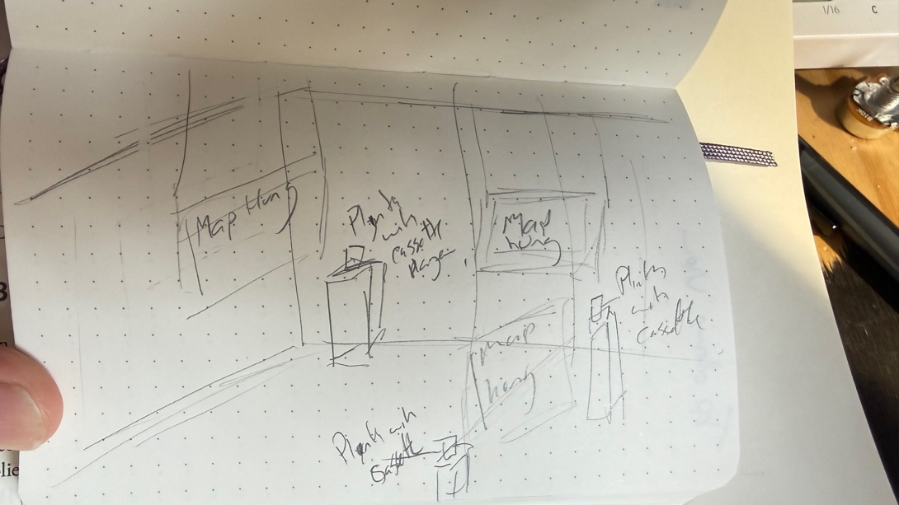
  - Provisional layout ideas

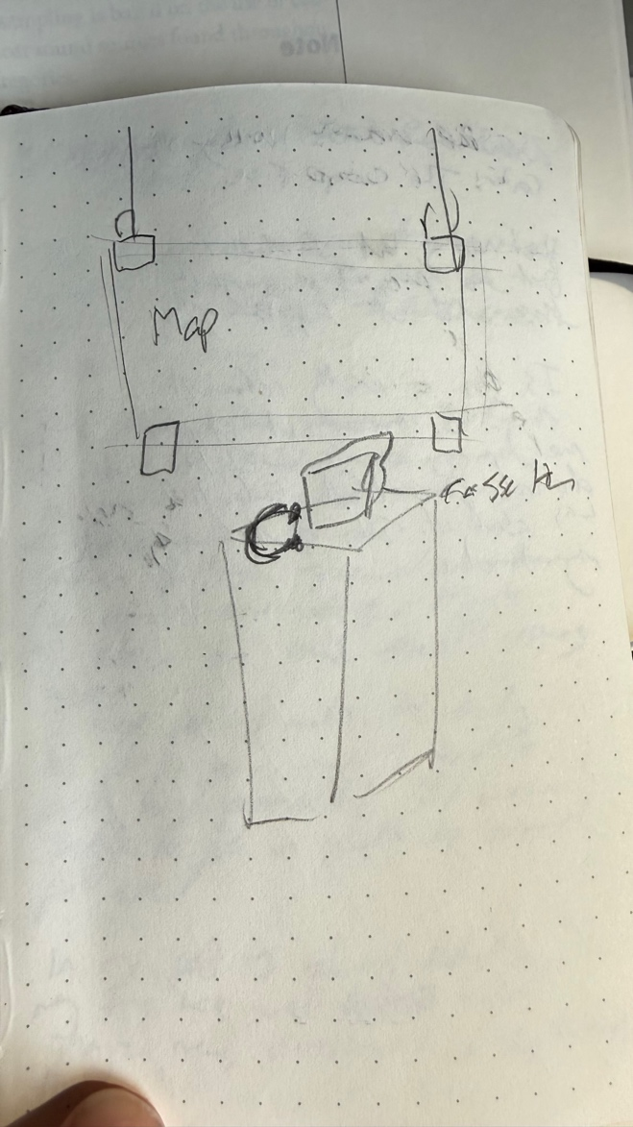 | 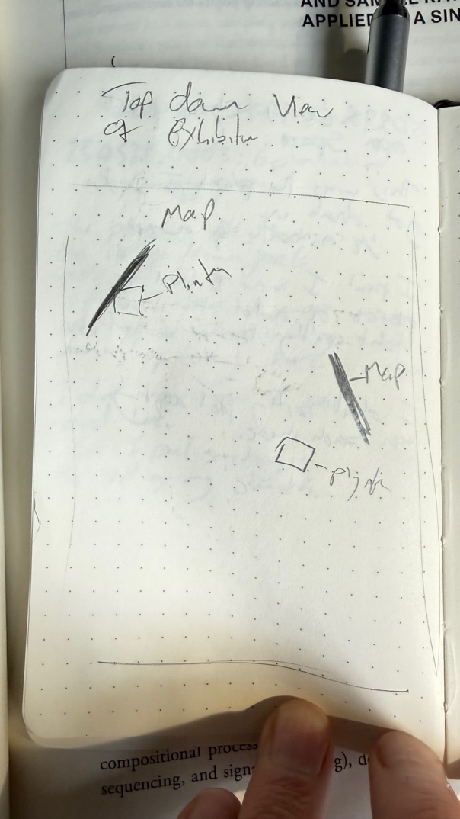
- Physical item & hung map | - Provisional idea for top-down view of exhibition

[1] S. Boym, The future of nostalgia. New York: Basic Books, 2001.
[2] M. Fisher, Capitalist realism is there no alternative? Winchester, UK: Zero Books, 2009.
[3] M. Fisher, Ghosts of my life : writings on depression, hauntology and lost futures, New edition / with introduction by Matt Colquhoun and Afterword by Simon Reynolds.. Winchester, UK: Zero Books, 2014.
[4] ‘Stepping into the Dark, by Chris Watson’, Chris Watson. Accessed: May 22, 2026. [Online]. Available: https://chriswatsonreleases.bandcamp.com/album/stepping-into-the-dark
[5] Derrida, Jacques, Specters of Marx. Routledge Classics, 2026.

